65 Years Later, Schools in US Remain Segregated
It's been 65 years since the historic ruling in Brown vs Board of Education case in which it was declared segregation in US schools was unconstitutional. Today, it seems that segregation still exists in today's schools.
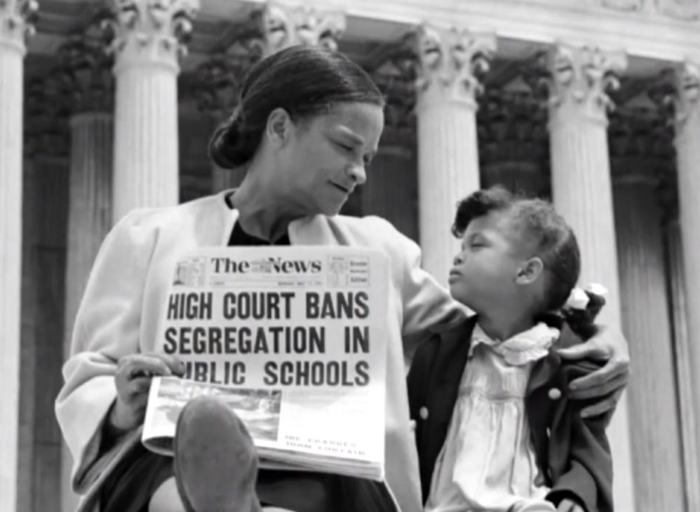
Nettie Hunt and her daughter Nickie on the Supreme Court steps holding a newspaper of the decision in Brown vs Board of Education. Courtesy of Corbis Images
Brown vs Board of Education: 65 Years Later
Perhaps one of the most notable and important cases to reach the Supreme Court would be that of Brown vs The Board Of Education (1954). This case was regarding the issue of school segregation in the United States. Thurgood Marshall would handle this case and argued the segregation between white and black students in schools was unconstitutional and the case had gained massive traction. This case arose due to multiple other cases that had occurred in Kansas, South Carolina, Virginia, Delaware, and Washington DC as tension on segregated school systems in the US grew. The case was argued for a period of two years until May 17, 1954 when Supreme Court Justice Earl Warren announced a unanimous decision that segregated schools in the US was a violation of the 14th amendment and therefore, it would be unconstitutional.

Brown vs Board of Education was an important turning point for desegregating the US at the time. The buildup to this case is what sparked so much attention and importance to it because the decision would make a huge impact to the Civil Rights Movement. It began with Plessy vs Ferguson in 1896 when the Supreme Court ruled segregated public places constitutional so long as the places for both blacks and white were equal. This led to the “Jim Crow Laws” which essentially barred African American students from going to school with white students as well as other restrictions. These laws would remain intact and unchallenged up until the 1950's when NAACP decided to challenge the laws on behalf of Delaware, South Carolina, and Virginia. The Supreme Court justices were unclear and divided on what to rule in which Fred Vinson insisted the decision of Plessy vs Ferguson should stand. It wasn't until Vinson's death in which Earl Warren would take his spot would help persuade the rest of the Supreme Court Justices to rule in favor of Brown and declared segregated schools unconstitutional and a violation of the 14th amendment.

The aftermath of the case was chaotic, as states in the South chose to resist and remain segregated while other states chose to comply. The Supreme Court never declared a way in which they would ensure schools wouldn't be racially segregated any longer which left some states the option to resist and not comply. As a result, the case itself did not immediately end segregation in schools but it was a huge victory for Civil Right activists and caused a sense of inspiration. Iconic national figures such as Rosa Parks or Martin Luther King rose after the ruling of the case and helped advance the Civil Rights movement further.

NYC Schools Remain Segregated
Despite the result of Brown vs Board of Education it has not been actively enforced throughout the US since. The New York City public system is a clear example of how modern segregation still exists in schools. Hets Online Journal discovered in studies that, as of March 2012 there are 1.1 million public school students in the New York City public school system which 40% are Hispanic, 32% are Black, 14% are Asian, and 14% are White. Given this information it is clear that New York City has a diversity of students attending public schools, however, New York is the most segregated state for black and Latino students in which seven out of eight black and Latino kids go to segregated schools. There is a massive portion of Black and Latino students that go to schools where no more than two to four percent of the children are white. This study helped highlight just how New York City is amongst one of the most segregated school systems in the US.
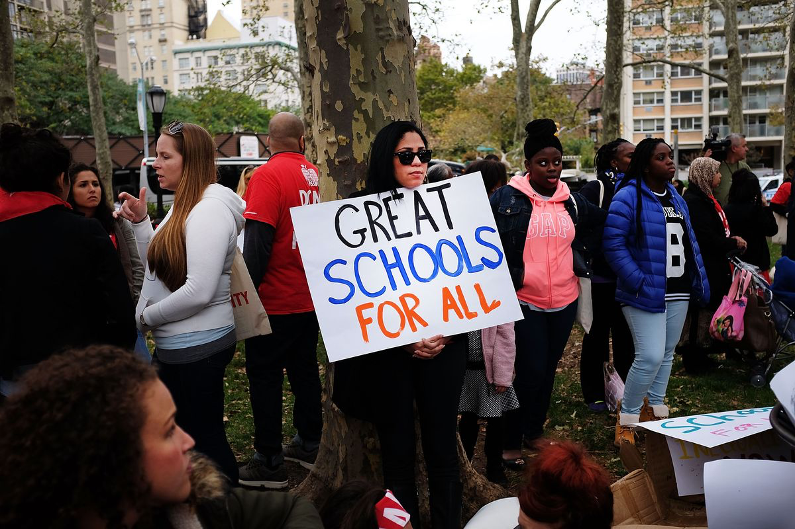
A woman protesting the inequality in NYC schools on October 7, 2015. Courtesy of Spencer Platt from Getty Images

In addition, a study conducted by UCLA discovered that in the past 20 years white students have become used to going to school with other white students while Hispanic and Black students feel uncomfortable when they are in a classroom with white students. These studies highlight the way in which the New York City public school system is segregated despite the city being one of the most diverse in the US.

Segregation in Chicago Schools
Chicago has also been a state in the US in which schools are segregated. Chicago is also known for having highly segregated schools in which it has stayed the same with very little progress over the years. In March 2017, a report released by The Urban Institute in partnership with the Metropolitan Planning Council released a report which indicated the following, “One of the three important findings in this research was that Chicago continues to struggle as a highly segregated metro area, which has major effects for all residents. The report goes on to state that Chicago is among the highest in the nation with re­gard to racial and economic segregation and that Blacks and Whites do not reside near one another in the city…”. Chicago is racially divided which leads to the segregation in schools in which whites go to school with mostly white white people and black people go to schools predominantly with black people.
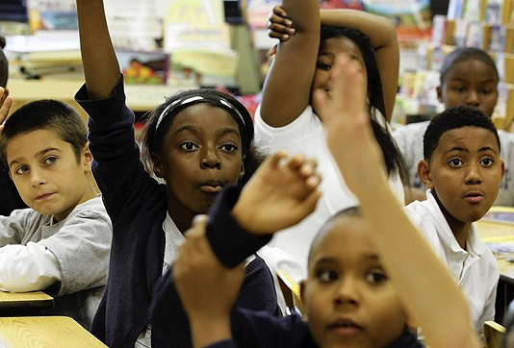
A picture taken at a Chicago public school. Courtesy of Chicago Tribune
The Reality
Since Brown vs Board of Education in 1965, its evident there has been a change in the way segregation exists in US schools. There is no rule prohibiting black students from going to school with white students but the segregation in schools remains because of the economic situation minorities go through. Since the decision made by the Supreme Court, students of black and Hispanic race have continued to attend schools with less resources while white students have continued to excel and have schools with vast resources. The reality is, the parents and the children themselves must realize the inequality and unfairness and stand up for themselves and create a path for the change they want.

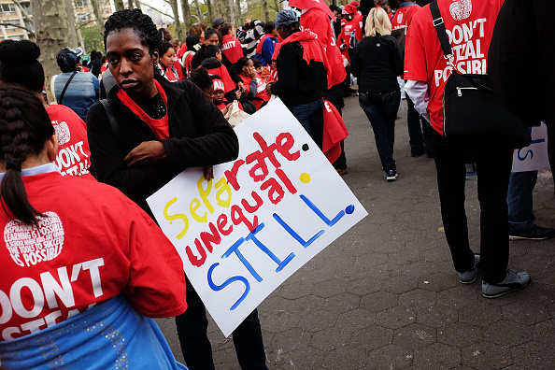
Civilians gathered in Brooklyn demanding a change in the inequality in education in NYC. Courtesy of Spencer Platt from Getty Images
Works Cited

Lockhart, P.R. “65 Years after Brown v. Board of Education, School Segregation Is Getting Worse.” Vox, Vox, 10 May 2019, https://www.vox.com/identities/2019/5/10/18566052/school-segregation-brown-board-education-report.

Moser, Whet. “Chicagoland Schools: For Blacks, the Most Segregated in the Country.” Chicago Magazine, http://www.chicagomag.com/Chicago-Magazine/The-312/September-2012/Chicagoland-Schools-For-Blacks-the-Most-Segregated-in-the-Country/.

“62 Years After Brown v. Board Of Education: Why Racial Segregation Is Up In U.S. Schools.” Diane Rehm, https://dianerehm.org/shows/2016-05-19/62-years-after-brown-v-board-of-education-why-racial-segregation-is-up-in-u-s-schools.

